# CS 255 System Design Document Template

This template lays out all the different sections that you need to complete for Project Two. Each section has guidance to prompt your thinking. You will need to continually reference the interview transcript as you work to make sure that you are addressing your client’s needs. There is no required length for the final document. Instead the goal is to complete each section based on what your client’s needs are. Remove this note when you are finished, and replace all bracketed text with the relevant information.

## UML Diagrams

### UML Use Case Diagram

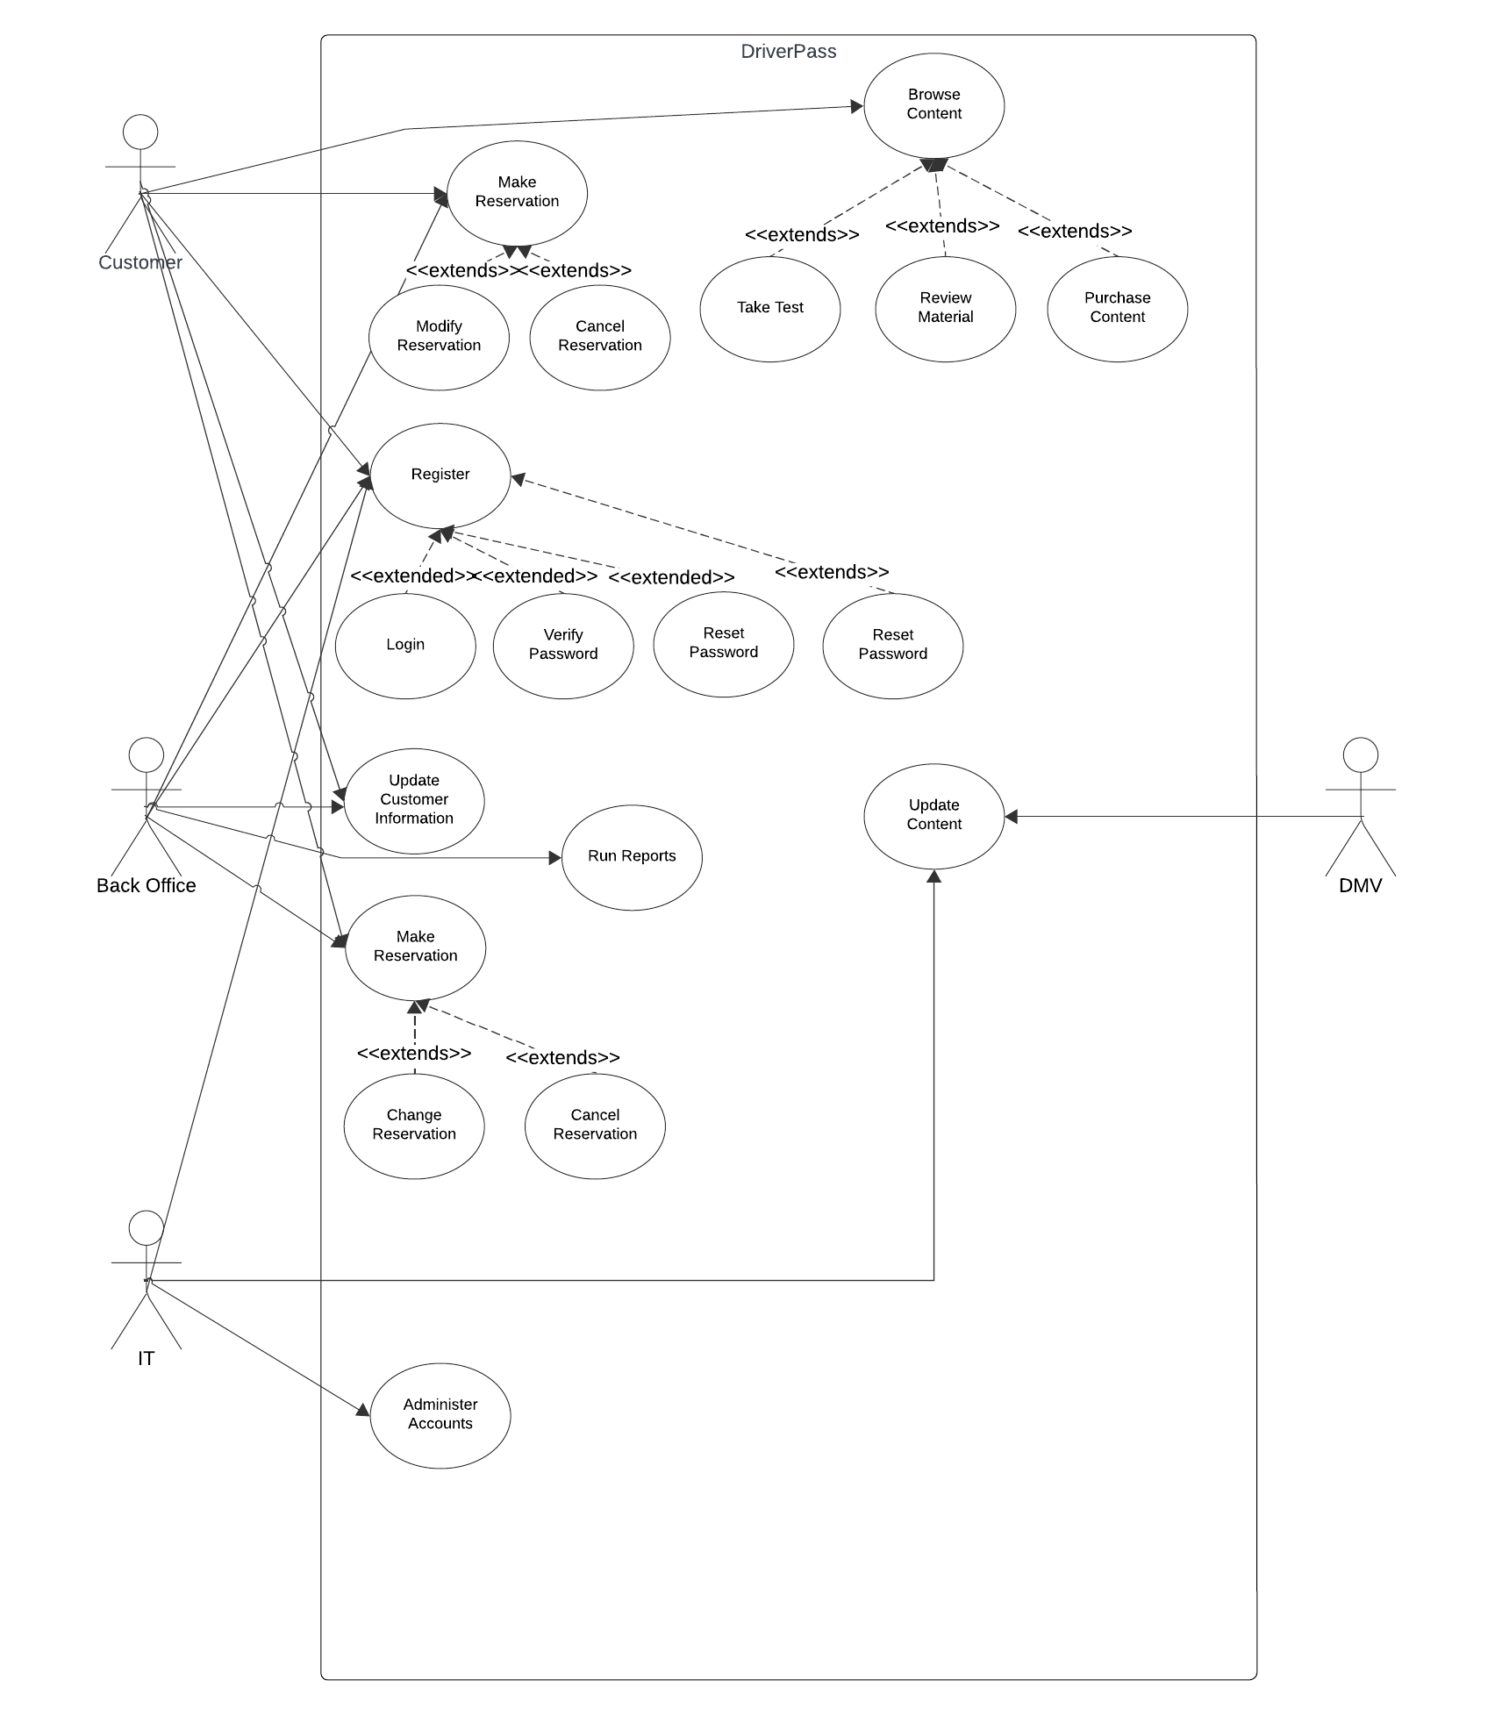

### UML Activity Diagrams

Activity Diagram: Browse Content

Activity Diagram: Make Reservation

### UML Sequence Diagram

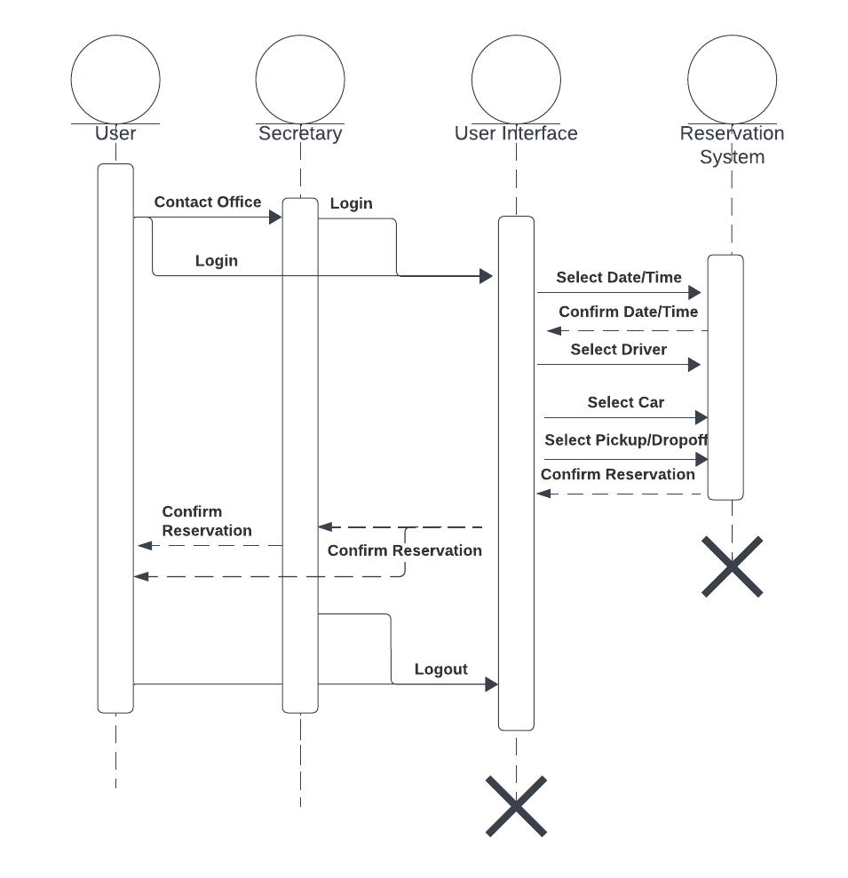

### UML Class Diagram

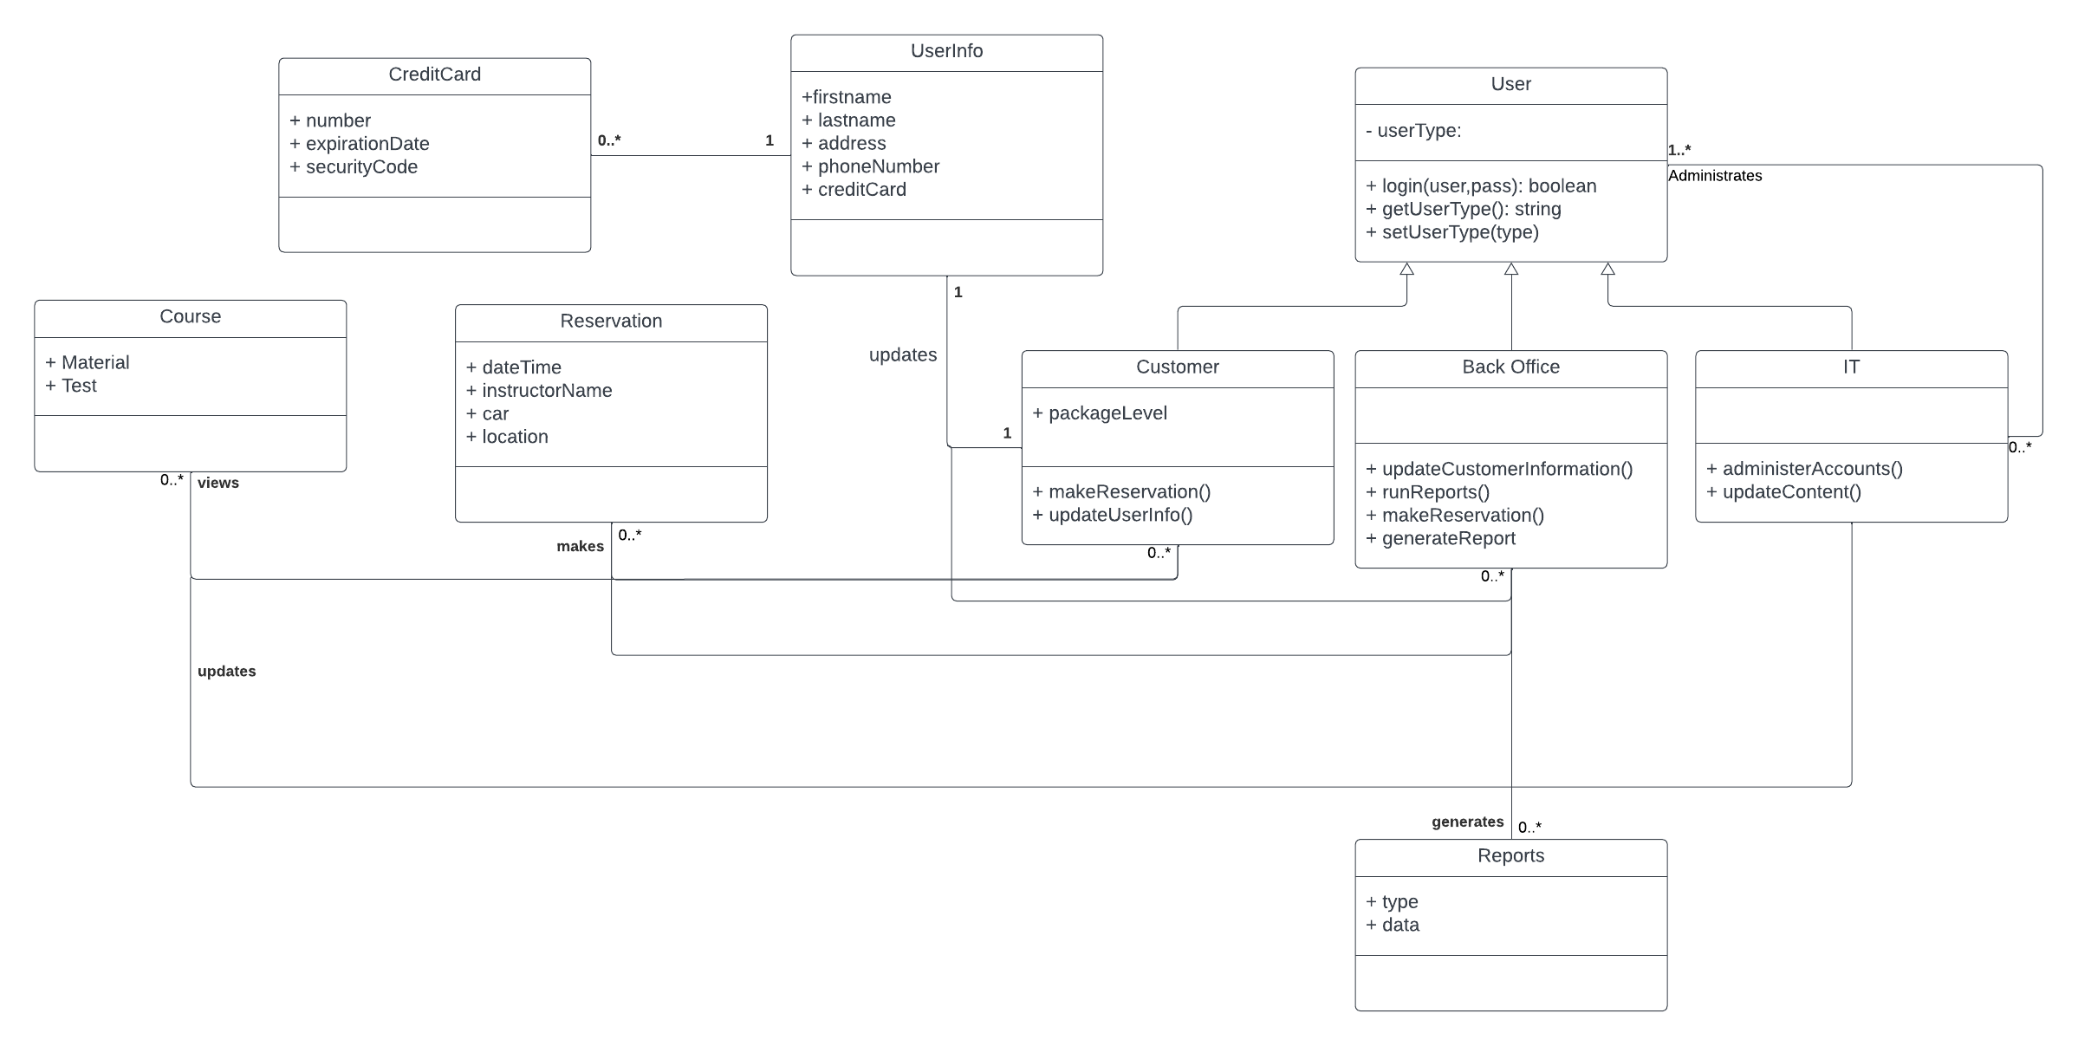

## Technical Requirements

Because this is a cloud-based system, most commercial-off-the-shelf products will work for the user interface. This supports the requirement that users can access it from the web. This means the system will be OS agnostic, but needs to support multiple browsers such as Chrome, Firefox, Edge and Safari. Based on cost, support, and user-friendliness, office staff should use Windows 11 OS. The minimal hardware requirements for Windows 11 are as follows:  
  
CPU: 1 Ghz or faster CPU with 2 or more cores  
RAM: 4GB

Storage: 64 GB  
Firmware: UEFI and Secure Boot Capable  
TPM: 2.0  
Graphics: DirectX 12 or later  
Display: HD 720p at least 9” diagonal  
Internet Connectivity  
(Microsoft)  
  
The IT department will administer accounts with Microsoft’s Active Directory. There will be a central storage system for the office to stage content before it is pushed to the cloud service, otherwise all company data will be stored on the cloud. This is a choice made by DriverPass so they don’t have to worry about local backup and security of the system.

*Microsoft*. Microsoft Support. (n.d.). https://support.microsoft.com/en-us/windows/windows-11-system-requirements-86c11283-ea52-4782-9efd-7674389a7ba3